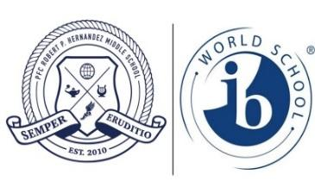
TV/Video Production Syllabus
Hernandez Middle School
Mr. Smosna - Room: 618
Course Description
TV/Video Production consist of introduction to video editing and news broadcasting strategies in the middle school environment. Students will learn the process of planning for a television or video production. They will learn the pre-production, production, and post-production stages of videoing an event. Students will gain knowledge in the following areas: Video editing, camera angles, lighting, reporting, broadcasting, photography & video photography, audio, computer generated graphics, editing, Youtube. Upon successful completion of this course, the student will be able to demonstrate a working knowledge of the equipment used in a television production in a studio or in the field. Also, the student will be expected to create a. an online / virtual portfolio of the skills learned in this course, as well as a Youtube channel with materials and videos created in this course.

Univision
Univision Television Broadcast Company (an American Spanish language broadcast television network that is owned by Univision Communications) has partnered with Hernandez Middle School. Members of Univision will be helping students to gain further knowledge in the TV/Video industry. Students will be able to receive advice and input from professionals in the TV/Video industry – making the course unique and also providing an amazing opportunity for students! Students will truly get to see the “real-world” applications of TV/Video Production with the help of Univision.

Technology
Students will learn Computer software will include (but is not limited to) Microsoft Office 2013, Adobe Premiere CS6, youtube, google sites, other google apps, and Adobe Photoshop CS6. Students will also be using both cameras and video cameras, microphones, uploading cables, and other television production equipment.

TV/Video Production Syllabus

Make-up work
Make-up work consists of assignments given while the student was absent excluding warm-ups. This does not include assignments due while absent, which should be turned in on the day of return to school. Make-up work necessitated by absences will be due within 5 school days of the student’s return to school.

Late work is work consisting of assignments not turned in on time although the student was present. 10% will be taken off the score (per day) for every assignment that is late. Students must to finish work to be successful on later assignments. All assignments can be corrected to receive 70% of points earned on the assignment.

All work during a marking period is due by the end of the marking period to receive credit. Work for a previous marking period will not be accepted.

Attendance
It is important that students are here and are actively engaged with the course material, whether note-taking, working with technology, sketching and brainstorming, or working on specific assigned projects. Students will be marked absent or tardy in accordance with Hernandez MS policies.

Equipment
Students will be required to supply their own writing utensils and spiral notebook or binder with notebook paper (it will only be a small part of the notebook and I will also provide scratch paper). Students will be charged for the cost of repairing or replacing of intentional misuse or destruction of tools, equipment, or projects.

Classroom Expectations
1. Be in your assigned seat when the tardy bell rings and stay there unless otherwise told.
2. Be prepared for class with materials, assignments and a positive attitude.
3. Follow all teacher directives immediately.
4. Be respectful to all and expect respect from others.
5. NO FOOD OR DRINK in class (a water bottle with a lid is acceptable)

IB mission statement
The International Baccalaureate aims to develop inquiring, knowledgeable and caring young people who help to create a better and more peaceful world through intercultural understanding and respect.
To this end the organization works with schools, governments and international organizations to develop challenging programmes of international education and rigorous assessment.
These programmes encourage students across the world to become active, compassionate and lifelong learners who understand that other people, with their differences, can also be right.

TV/Video Production Syllabus

Student Assessment
Assessment for design courses in all years programme is criterion-related, based on four equally weighted assessment criteria: 1. Inquiring and analyzing 2. Developing ideas 3. Creating the solution 4. Evaluating.
Each criterion has eight possible levels of achievement (1–8) *see below* Students will receive a percentage based grade in Teacher Access Center (the gradebook management software for RRISD). However, students will also receive criterion based achievement assessment based on chart below.

CTE Proficiency Scales
Proficiency Level | IB | Percentage
Advanced | 8 | 96-100
 | 7 | 86-95
Proficient | 6 | 76-85
Developing | 5 | 70-75
 | 4 | 65-69
 | 3 | 60-64
Limited | 2 | 55-59
 | 1 | 45-54

TV/Video Production
Student and Parent Syllabus Signature Page
Hernandez Middle School
Mr. Smosna Room: 618

I have read, I understand, and agree to the terms outlined in this syllabus. I agree to complete all assigned work to the best of my ability. I understand that I will be working extensively with technology hardware and software both inside and outside of the classroom and that I must use the technology responsibly. I understand that there will be occasions that I will be on both local and national news stations. I also understand that if I select to make my youtube channel public it will be visible for anyone to see.

Student signature Date

Parent signature Date

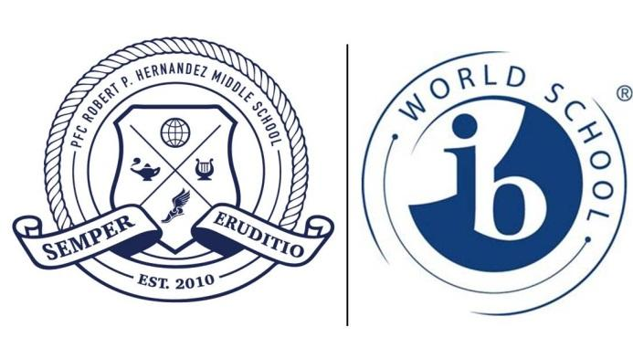
Home phone: _____________________________

Work phone: _____________________________

Parent email: _____________________________

